[Geophysical Services Landing Page]
[Icon]
Geophysical Services

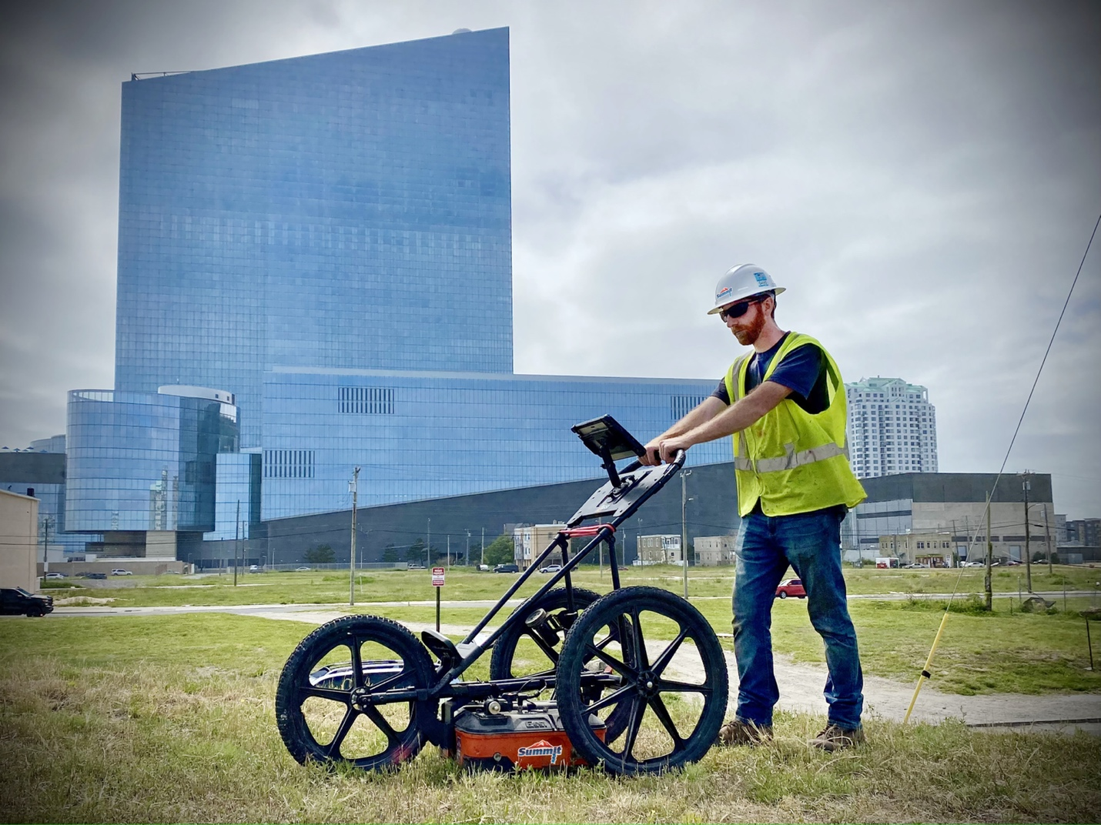

[Text]
Summit’s Geophysical Services and growing geophysics division provide a full array of real-time geophysical services to the environmental, engineering, and construction industries.
Our multi-faceted approach includes:
• Ground Penetrating Radar
• Radio Frequency Line Locating
• Electromagnetic Scanning
• Resistivity Profiling

Our combination of equipment and experienced geophysicists enable us to detect private utilities, underground storage tanks (tank sweeps), drums, septic structures, borehole bedrock fractures, excavations, rebar and more.

Summit’s geophysical services are supported by one of the industry’s largest teams of full-time professional geologists and highly experienced geophysicists with multiple crews dispatched daily. Each crew is equipped with the latest in geophysical technology, including ground penetrating radar, electromagnetic scanning, radio frequency line locating equipment, and high-tech drones.

Our combination of equipment and experience is unequaled. Customers count on us for a wide range of services from near-surface infrastructure detection to precise downhole geophysics and logging. Summit is a trusted source for pre-drilling or pre-excavation clearance, private utilities, underground storage tanks (tank sweeps), drums, septic structures, rebar, landfill and buried waste delineation, karst terrain and bedrock mapping, and electrical resistivity profiling.
Our multi-faceted geophysics division provides a full array of real-time geophysical services to the environmental, engineering, and construction industries.

For more information on our multi-faceted services approach, email Lauren DiVello at LDivello@summitdrilling.com. You can also use our convenient Start-a-Project form below to provide details about your scope of work and upload reference documents. A Summit representative will respond promptly.

[Utility Locating Page]
[Icon]
Utility Locating

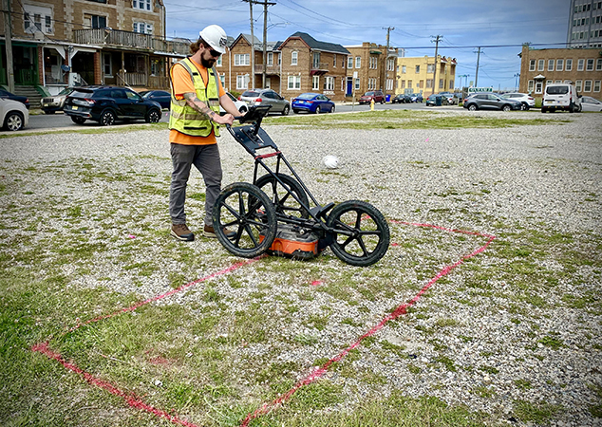

[Text]
Utility Locating
Utility locating is a critical process that helps prevent accidents, protect the environment, and ensure the efficient and safe execution of construction, excavation, drilling and maintenance activities.
Summit’s geophysical professionals utilize a wide variety of technology, including:
• Radio Frequency (RF) line locator
• Fisher TW-6 electromagnetic instrument
• Ground Penetrating Radar (GPR)
• Duct Rodder (fiberglass wrapped tracing line)
• EM61, EM31 electromagnetic instruments
• Sub-meter GPS
• Drone aerial to memorialize the mark outs

Utility locating or detection, is the process of identifying and marking the location of buried utility lines and infrastructure beneath the ground. These utilities can include various types of pipes, cables, and conduits that provide essential services such as water supply, sewage, electricity, telecommunications, natural gas, and more. The primary purpose of utility locating is to prevent damage to these underground utilities during construction, excavation, or drilling activities.

Key Applications
• Summit Private Utility Location. We address everything that is not covered by a one-call such as, water from valve to meter, sanitary sewer from cleanout to building, storm sewers, privately run electric lines, floor drains, oil/water separators and septic.
• Preferrable Pathway Evaluations. This involves the identification of utility corridors typically at the entrance of a building. Our services help customers target vapor intrusion investigations.
• Gas Stations
• One Call Mark Out Confirmations. As many consultants and engineers know, One Calls are not always accurate as utility companies may bot clip on to the utility and frequently use plans that are not as comprehensive compared to “as-builts”.
Tech/Instrumentation/Tools
Summit’s geophysical professionals utilize a wide variety of technology, including:
• Radio Frequency (RF) line locator
• Fisher TW-6 electromagnetic instrument
• Ground Penetrating Radar (GPR)
• Duct Rodder (fiberglass wrapped tracing line)
• EM61, EM31 electromagnetic instruments
• Sub-meter GPS
• Drone aerial to memorialize the mark outs
Utility locating is a critical process that helps prevent accidents, protect the environment, and ensure the efficient and safe execution of construction, excavation, drilling and maintenance activities.
For more information on our multi-faceted services approach, email Lauren DiVello at LDivello@summitdrilling.com. You can also use our convenient Start-a-Project form below to provide details about your scope of work and upload reference documents. A Summit representative will respond promptly.

[UST & Septic Detection]

[Icon]
UST & Septic Detection

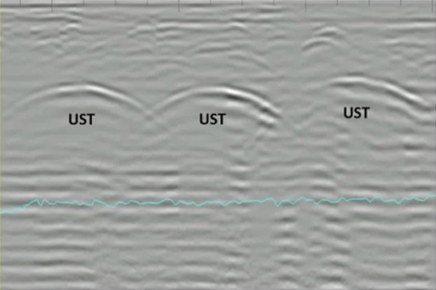

[Text]

UST & Septic Detection
The importance of locating USTs or detecting septic systems lies in the prevention of environmental contamination, protection of human health and safety, adherence to regulators, and potential cost savings.
Summit’s geophysical professionals utilize a wide variety of technology, including:
• EM61
• EM31
• Fisher TW-6 electromagnetic instrument
• Ground Penetrating Radar (GPR)
• Radio Frequency (RF) line locator

Locating underground storage tanks (USTs) and detecting septic systems is of significant importance due to the potential risks and benefits associated with their identification, management, or removal. There are several reasons to consider these services, including: environmental protection, environmental remediation, health and safety, regulatory compliance, and property transaction and development.
Key Applications
• Full property sweeps for orphaned/unknown USTs
• Known UST footprint and orientation delineation
• Septic structure detection (sub-grade tanks, distribution boxes, leach fields, laterals, and other
piping, etc.)
• Property transactions and/or unknown source evaluations
Tech/Instrumentation/Tools
• EM61
• EM31
• Fisher TW-6 electromagnetic instrument
• Ground Penetrating Radar (GPR)
• Radio Frequency (RF) line locator
The importance of locating USTs or detecting septic systems lies in the prevention of environmental contamination, protection of human health and safety, adherence to regulators, and potential cost savings. It is a proactive measure that not only mitigates risks but also facilitates responsible property management and development.
For more information on our multi-faceted services approach, email Lauren DiVello at LDivello@summitdrilling.com. You can also use our convenient Start-a-Project form below to provide details about your scope of work and upload reference documents. A Summit representative will respond promptly.

[Borehole Geophysics]

[Icon]
Borehole Geophysics

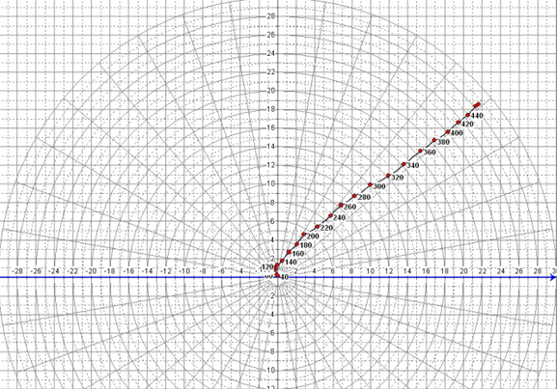

[Text]

Borehole Geophysics
Borehole geophysics is a valuable technique for characterizing subsurface conditions and obtaining data for a variety of geological, hydrogeological, and environmental applications.
Summit’s geophysical professionals utilize a wide variety of technology, including:
• Optical Televiewer
• Acoustic Televiewer
• Caliper
• Temperature/Fluid Resistivity
• GR/SP/SPR
• Heat Pulse Flowmeter
• Full Wave Form Sonic
• Well CAD

Borehole Geophysics, also know as well logging or downhole geophysics, is a subsurface exploration technique used to obtain geophysical data from within boreholes or wells drilled. It involves the use of specialized instruments and sensors to collect data on geological, hydrogeological, and geophysical properties at various depths below the surface.

Key Applications

This technology is conducted to gather information on the geologic and hydrogeologic interpretation in open boreholes. It is used to identify specific structural characteristics of the borehole (fractures, fracture zones, voids, bedding planes, etc.), lithology, water bearing zones, and vertical flow conditions to target for well construction purposes. It can also be used to identify areas of contaminant presence and its migration.

Borehole Geophysics

Borehole geophysics is a valuable technique for characterizing subsurface conditions and obtaining data for a variety of geological, hydrogeological, and environmental applications.

Summit’s geophysical professionals utilize a wide variety of technology, including:
• Optical Televiewer – 360-degree visual color presentation of borehole conditions that include geologic structures (fractures, bedding planes, voids, etc.), lithology (color changes), and stratigraphic conditions. The strike and dip of individual fractures and bedding can be determined, and polar projection plots showing bulk strike and dip orientations over specified intervals can be generated. Borehole deviation logs can be generated from the data, as well. Can be used in air or water-filled boreholes.

• Acoustic Televiewer – Similar to the optical televiewer, however an acoustic signal is used as an energy source. Also used to locate fractures, bedding planes, etc., and the data can be used to determine strike and dip of these features. Polar projection plots can also be generated. Can be used in boreholes where some suspended sediment is present. Can be used in water-filled boreholes, but not air-filled boreholes.

• Caliper – provides a continuous record of borehole size versus depth in the borehole. Is often used to locate fractures or anomalous borehole wall conditions.

• Temperature/Fluid Resistivity – Fluid resistivity – delineating potential water-bearing zones. Changes in the slope of the responses may indicate a water entry, or water exit points in the borehole. Temperature – measures changes in water temperature which can also be correlated to water bearing zones. Again, changes in slope indicate potential water bearing zones.

• GR/SP/SPR

• SP – Spontaneous Potential – measures natural difference between borehole and surface, most useful to determine electrochemical potential. Magnitude of deflection used to detect permeable zones, estimate clay content, and water salinity. Good as a lithology indicator.

• SPR – single point resistance – characterizes rock or sediment in the borehole by measuring the electrical resistance of the formations. It is a good lithologic indicator.

• GR – Natural Gamma Ray – good lithologic indicator. The data can identify and quantify the amounts of specific isotopes (potassium, thorium, and uranium) in boreholes. Used as a lithologic indicator to differentiate between fine-grained materials (e.g., clays and shales with high potassium content, etc.), and coarse-grained materials (e.g., sands and sandstones with a low potassium content, etc.). Can be used to infer depositional environments, and to correlate structural and stratigraphic features from borehole to borehole.

• Heat Pulse Flowmeter – measures minute changes in vertical flow at specific depths. The data can indicate the presence of water-producing zones and water-thieving zones.

• Full Wave Form Sonic – Used to determine the integrity of grout in the annulus behind casing and to locate fracture zones and weathered zones in an open borehole. The data can be processed to generate acoustic porosity curves, as well.

• Well CAD software for processing and analysis of logging data.
Borehole geophysics is a valuable technique for characterizing subsurface conditions and obtaining data for a variety of geological, hydrogeological, and environmental applications. It plays a significant role in environmental assessments and engineering projects, providing essential information for approach development and risk mitigation in subsurface activities.

For more information on our multi-faceted services approach, email Lauren DiVello at LDivello@summitdrilling.com. You can also use our convenient Start-a-Project form below to provide details about your scope of work and upload reference documents. A Summit representative will respond promptly.

[Electrical Resistivity]

[Icon]
Electrical Resistivity

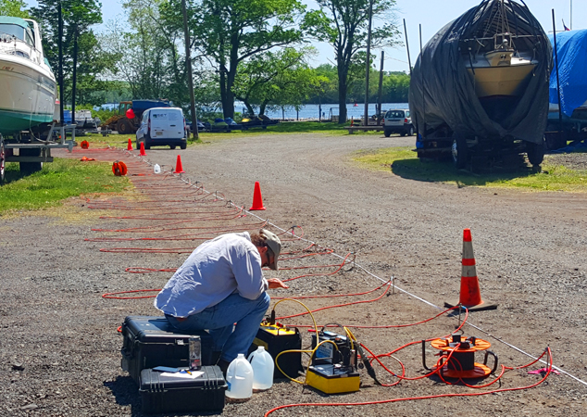

[Text]
Electrical Resistivity
Electrical conductivity and resistivity measurements provide valuable information about the subsurface properties of materials, helping professionals make informed decisions in a wide range of applications, from environmental assessments and resource exploration to civil engineering and archeology.
Summit’s geophysical professionals utilize a wide variety of field applications, including:
• Identify near surface geologic and hydrogeologic features
• Bedrock surface, clay layers, cavities/sinkholes/voids, karstic features, depth to groundwater, and possible contaminant presence
• Property/infrastructure development

Electrical Resistivity measures the electrical resistivity of subsurface materials. It is predominantly used for environmental and geotechnical studies to assess soil and groundwater contamination, locate buried infrastructure and study geological formations.
Key Applications
• Identify near surface geologic and hydrogeologic features and existing subsurface conditions.
• Bedrock surface, clay layers, cavities/sinkholes/voids, karstic features, depth to groundwater, possible contaminant presence. Cross-sectional images of the subsurface are generated to typical depths of 100 feet or more.
• Property/infrastructure development, used prior to, or in conjunction with geotechnical borings.
Tech/Instrumentation/Tools
AGI SuperSting R8IP Earth Resistivity Meter – measures voltage drop of an induced electrical current across numerous electrodes as it travels through an electrically heterogeneous subsurface. EarthImager processing software is used to generate cross-sectional electrical resistivity images.
Electrical conductivity and resistivity measurements provide valuable information about the subsurface properties of materials, helping professionals make informed decisions in a wide range of applications, from environmental assessments and resource exploration to civil engineering and archeology. These measurements aid in understanding the physical and chemical characteristics of the Earth’s subsurface and contribute to more effective problem-solving.
For more information on our multi-faceted services approach, email Lauren DiVello at LDivello@summitdrilling.com. You can also use our convenient Start-a-Project form below to provide details about your scope of work and upload reference documents. A Summit representative will respond promptly.

[Seismic Refraction]

[Icon]
Seismic Refraction

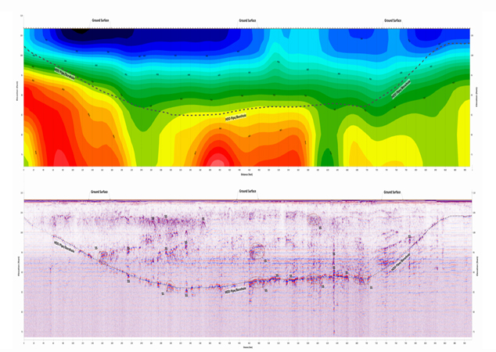

[Text]
Seismic Refraction

Seismic Refraction is a valuable geophysical technique used to study subsurface properties and provide insights into the geological and geotechnical characteristics of an area.
Summit’s geophysical professionals utilize a wide variety of field applications, including:
• Good estimates for depths to bedrock, consolidated beds and groundwater
• Determining the approximate velocities of geologic materials
• Rock rip ability
• Detecting intrusive geologic bodies
• Identifying structural features

Seismic Refraction is a geophysical technique used to study subsurface properties of the Earth, specifically the distribution of seismic velocity within near-surface geologic layers. Seismic waves travel through the Earth at different velocities depending on the properties of the materials encountered. Generally speaking, waves travel faster through dense or ridged materials and slower through less dense or malleable material. By analyzing the refractions of these waves, geophysicists can map subsurface structures and identify potential infrastructure and underground assets.

Key Applications
• Good estimates for depths to (a) bedrock (overburden thickness), (b) consolidated beds, and (c) groundwater. Good for generating 2-D profiles that show bedrock topography and lateral changes in compressional and shear wave velocity.
• Determine the approximate velocities of geologic materials, which may be related to rock type, water saturation, degree of weathering, and the presence of faults, fractures, and weathered zones (low velocities)
• Estimation of Poisson’s Ratio for geotechnical purposes
• Rock rippability (ease of mechanical excavation)
• Detecting intrusive geologic bodies.
• Identifying structural features.

Tech/Instrumentation/Tools

Geometrics – Geode 24-channel seismograph with 4-Hz or 14 Hz geophones, and a 12-16-pound hammer source. SeisImager 2D and SeisImager SW processing software are used to generate 2-D compressional and shear wave velocity images of the subsurface.

Seismic Refraction is a valuable geophysical technique used to study subsurface properties and provide insights into the geological and geotechnical characteristics of an area. It’s applications are diverse and include site investigations for construction to environmental assessments. By better understanding the subsurface, professionals can make more informed decisions to ensure the safety and success of their various projects.

For more information on our multi-faceted services approach, email Lauren DiVello at LDivello@summitdrilling.com. You can also use our convenient Start-a-Project form below to provide details about your scope of work and upload reference documents. A Summit representative will respond promptly.

